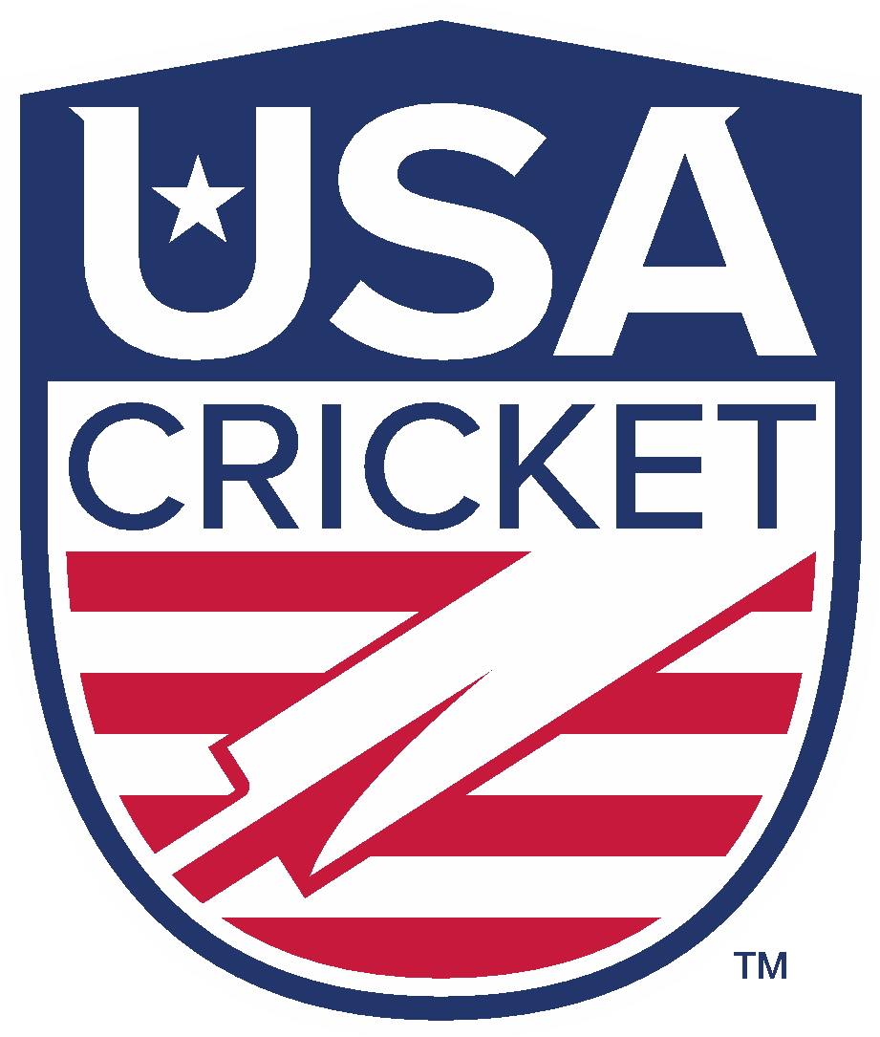
Expression of Interest in National Team Selection
USA Cricket was established in 2017 to act as the national governing body for the sport of cricket in the United States, and is recognized as an Associate Member of the International Cricket Council. It is a 501(c)(3) charitable nonprofit organization incorporated under the laws of the state of Colorado, but is now headquartered in the San Francisco Bay Area, California. Its mission is to govern, regulate, develop and promote the sport of cricket (including hardball, softball, disabled and all other types of cricket) at all levels in the United States, and to enable United States cricketers to successfully compete in national and international competition.
The purpose of this application is to identify those individuals who are interested in applying for a role in the selection of the USA women’s national senior and junior teams.
In order to be considered as part of this process, an individual must:
- Must have played international cricket (whether for the USA or any other country), first-class domestic cricket, List A cricket or T20 cricket for state/regional sides (in any country)
- The candidate must have retired from playing representative cricket for a minimum of one year
- Must currently live in the USA
- Must have a good understanding of the domestic and national cricket structures across the USA
- Must be passionate and enthusiastic about the development of the sport in the USA
- Must comply with the Conflict of Interest provisions within the Selection Policy
Applicants interested in a role in national team selection should first read and understand the USA Cricket Selection Policy, and submit a completed application by 11.59pm PT, May 22, 2023.
All completed applications should be sent by email to HR@usacricket.org.

- Candidate Name:

- Mailing Address:

Cell Phone:

Email Address:

- Employment:

Current Position:

Current Employer:
In addition to filling in the above, please attach a current resume.

- Please provide a summary of your cricket-playing experience.

- Please provide a summary of your experience in cricket administration over the past five years.

- Why are you interested in serving as a national team selector for USA Cricket?

- How do you feel USA Cricket would benefit from your involvement?

- Please share any other information you feel important for consideration of your application to play a role in national team selection:

- Please review and respond to the following questions. Use a separate sheet as necessary.

- Are you aware of any information about yourself, which might tend to reflect unfavorably on your reputation, morals, character or ability to act as a national team selector for USA Cricket?

Yes No If yes and would like to explain, use a separate sheet of paper.

- Have you ever been convicted of a felony?
Yes No If yes and would like to explain, use a separate sheet of paper.

- Have you ever been convicted of a controlled substance offense?

Yes No If yes and would like to explain, use a separate sheet of paper.

- Have you ever been convicted of a sex-related crime?
Yes No If yes and would like to explain, use a separate sheet of paper.

By signing below, I attest that the information I have provided is true and correct.

Signature:

Date:

